IOT Based Person/Wheelchair Fall Detection

When it comes to old age, it becomes necessary to monitor our old ones for their health and safety. Due to weakness and weak joints they have a great risk of falling down. Now it is important to know if an old age person has fallen so that he/she can be helped on time. Also people on wheelchair need to be checked for fall detection. For this purpose we propose a smart fall detection system. The system uses accelerometer and gyro sensor to detect person movements, It can be mounted on persons hand or wheelchair for detection. The sensor is connected to a microcontroller in order to constantly transmit the acceleration data. Now the system keeps monitoring for fall detection and abrupt movement changes in person. A sudden abrupt change with jerk in the system is treated as a fall. Now in case the person did not fall and alarm was false, the system allows to snooze the alert if person presses snooze button in 5 seconds. If person does not press the snooze, system detects person has fallen and automatically triggers alert through Wi-Fi connection to alert the loved ones of the person about the situation instantly.

Block Diagram:

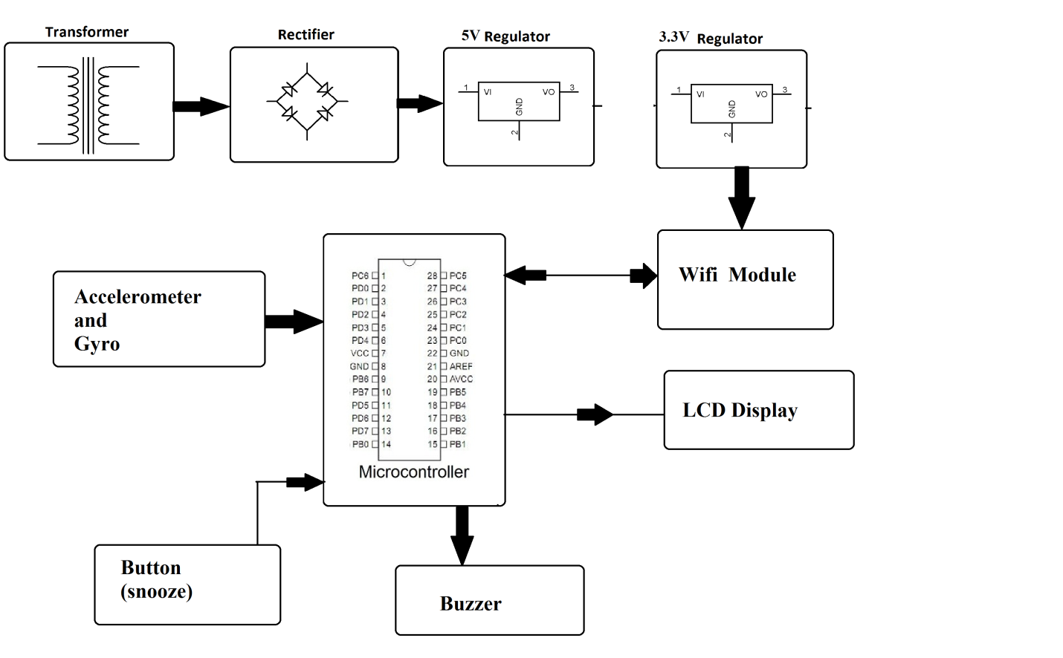

Hardware Specifications:
- Accelerometer Sensor
- Gyroscope Sensor
- Atmega 328 Microcontroller
- Wi-Fi Modem
- LCD Display
- LED’s
- Transformer
- Resistors
- Capacitors
- Diodes

Software Specifications:
- Arduino Compiler
- MC Programming Language: C
- IOTGecko

Reference
- http://ieeexplore.ieee.org/xpl/articleDetails.jsp?arnumber=7479018&queryText=iot%20elderly&newsearch=true

